Wi-Fi Cracking

**Do not try this on an access point that doesn’t belong to you!**

This tutorial requires a USB Wi-Fi dongle if you are waiting for one do the other tutorial in this folder.

First thing we need to do is load up the Cyber security Society VM in virtual box. Once it has loaded into Kali you need to allow kali to use the USB dongle shown below.

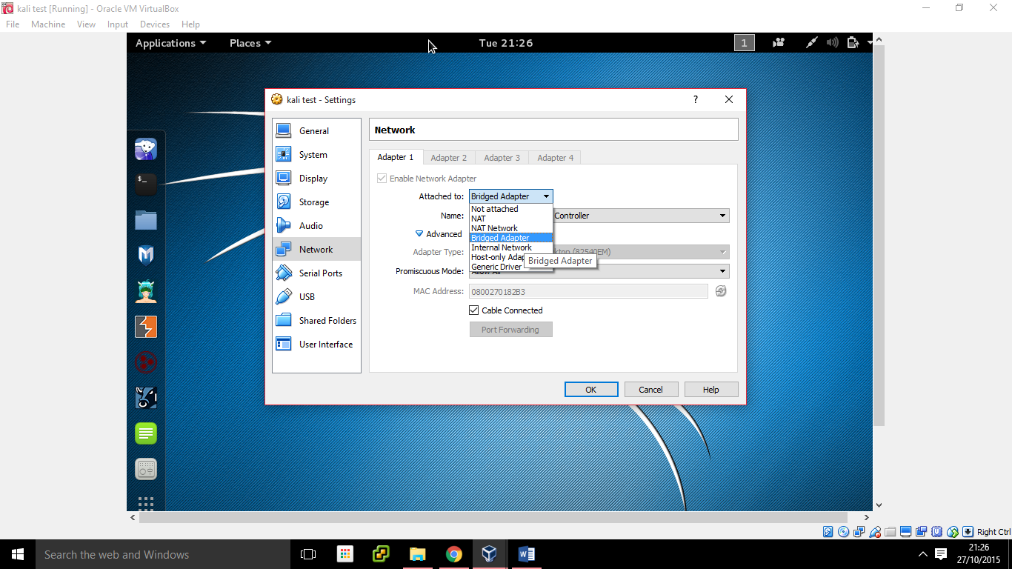

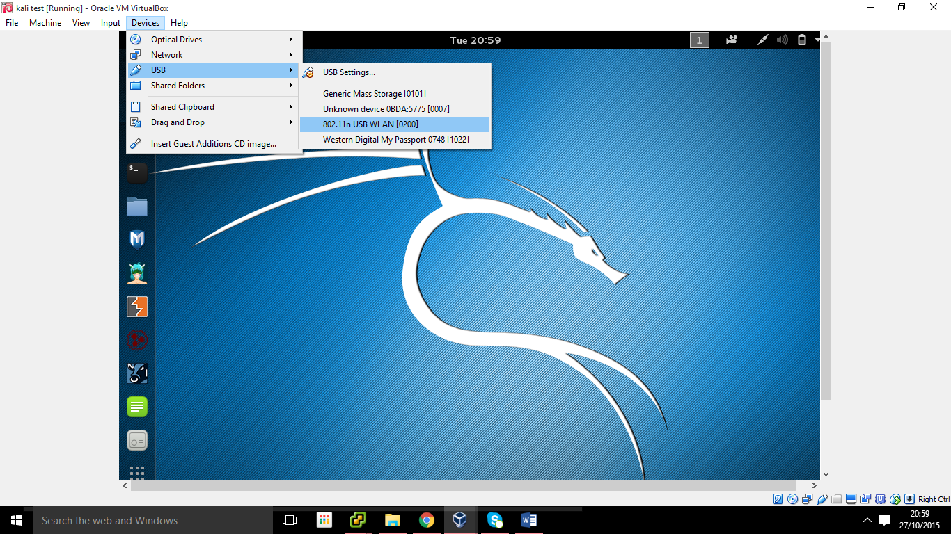

Once you have done this kali should be able to use the Wi-Fi dongle, you can check by clicking the icon next to sound in the top right it should say wireless not connected.

Next open a terminal as we need to find what the dongle interface is called and change the Wi-Fi mode to monitor mode.

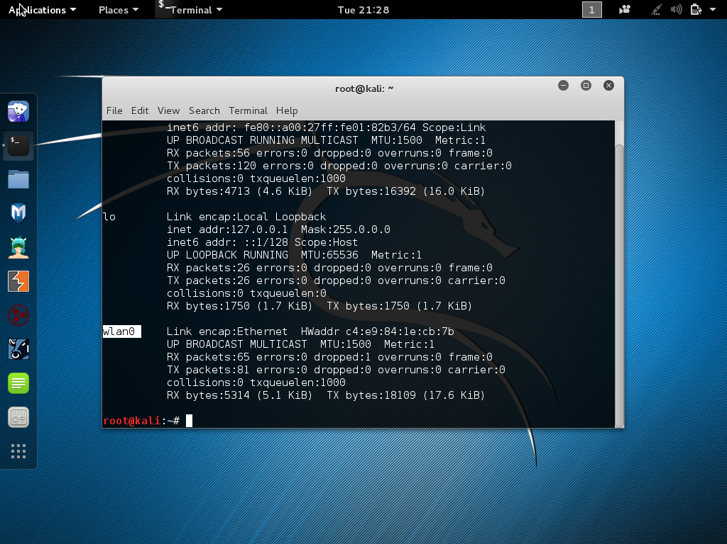

Above is the readout from the command ifconfig, the Wi-Fi uses wlan0 as its interface. Next we need to change the wlan0 interface to monitor mode. To do this we will use the command airmon-ng start wlan0. This will tell the tool airmon-ng to start monitoring on the WI-FI dongle( note if your interface had a different name use it not wlan0)

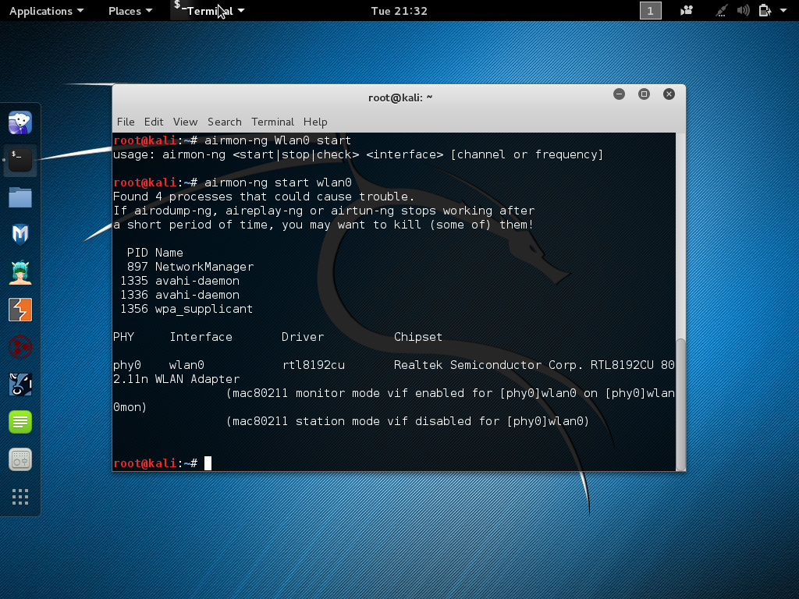

Above is the readout you should get. Next we need see the wireless networks around us by entering the command airodump-ng wlan0mon. ( if you get an error read below if not you can skip ahead)

If you get an error do the following commands

Ifconfig wlan0mon down

Iwconfig wlan0mon mode monitor

Ifconfig wlan0mon up

This should fix the problem as you manually put the Wi-FI dongle into monitor mode. Run the command airodump-ng wlan0mon again.

You should see this screen press ctrl c to stop the airodump-ng tool.

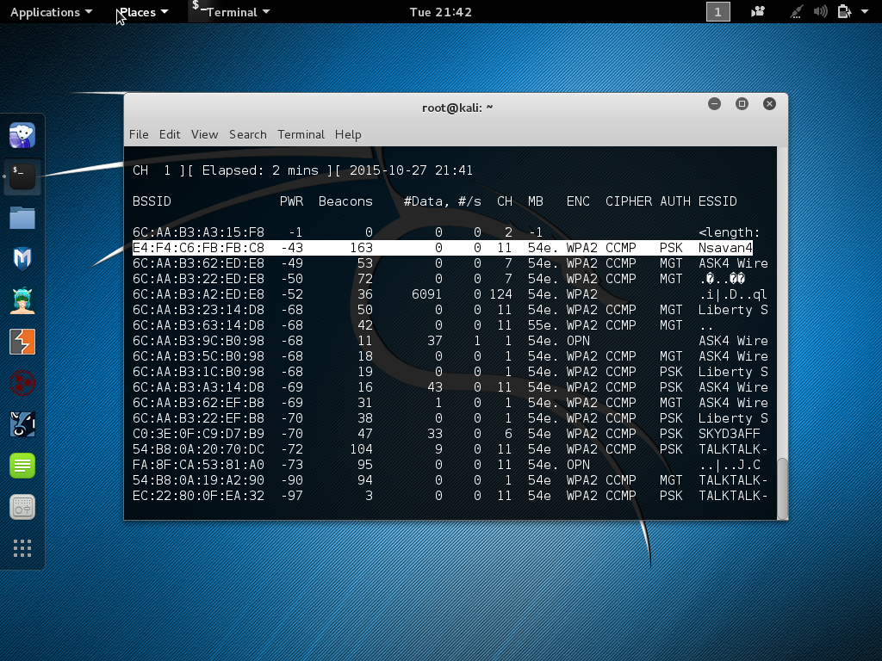

The wifi access point we want is Nsavan4 as its owned by me and uses PSK as the authentication (The basic enter a password). You should now make a file to store the BSSID and ch (channel) number in for later.

Next enter

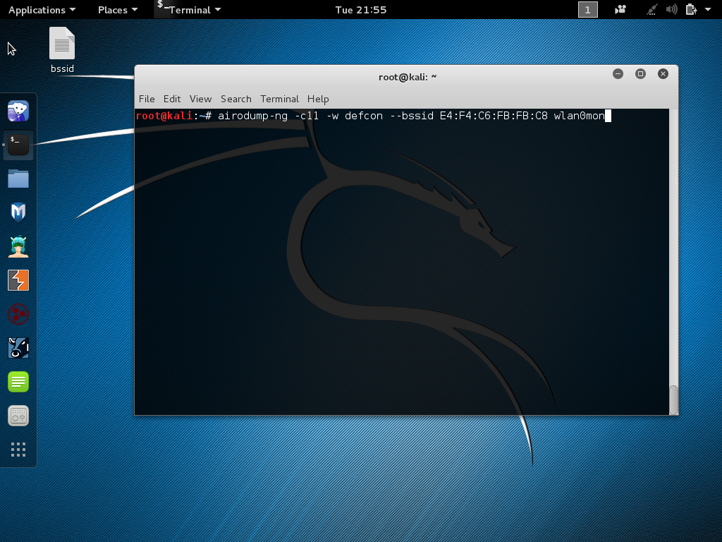

This monitors the access point and will save the password hash to the file called defcon-01.cap.

You will now see all the devices connected to the access point there should be one. (my phone) open a new terminal and enter the following command to kick my phone from the wireless so that it re-joins and will give us the password hash(hand shake).

Aireplay-ng -0 0 –a put the bssid of the phone here then wlan0mon

Let this run for around ten seconds then ctrl c to stop it, go back to the other terminal my phone should then reconnect then you should see this.

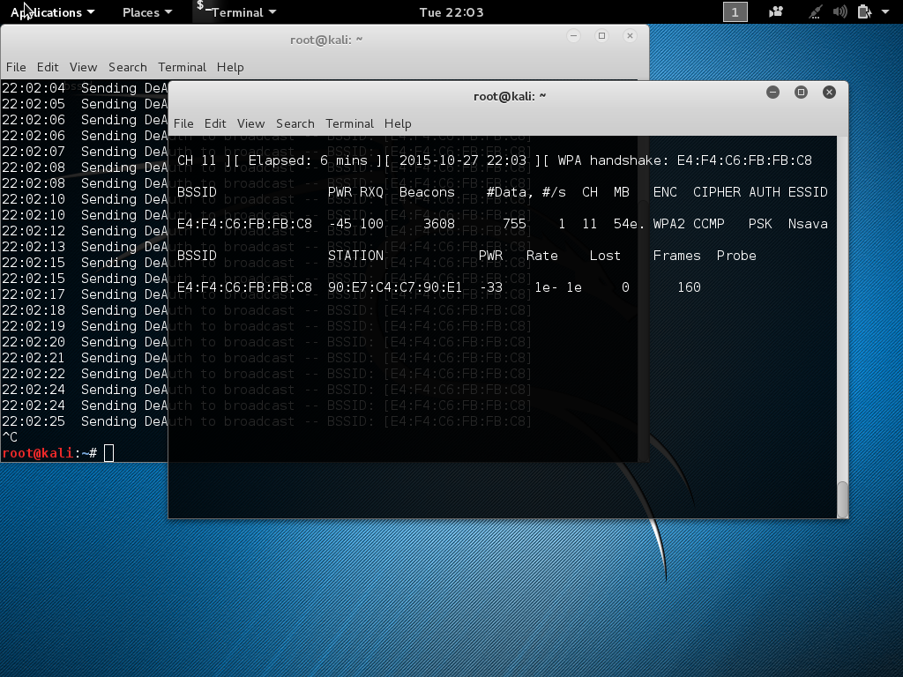

If you see this it means you have successfully captured the password hash.

Now we need to try it against a password file I have made one called wordfile.txt. (This file should be on the desktop if not tell me and I will give you it)

If you do Ls you should see a file called defcon-01.cap. The hash is saved here so we will now enter the following command to test it against are password file.

Aircrack-ng –w /root/Desktop/wordfile.txt defcon-01.cap

Once you hit enter you it should start to try and crack the hash

Once it has finished it will say the password.

Now try the second tutorial and give someone else the dongle.